4233299 - Division - Eliminating Balance Type
Division enhancement: Eliminating Balance Type and Journal Entries (Epic 4233299)1. Customer Problemtransactions are hard to track without a dedicated Eliminating layer across JE, reports, add-in, and exports.
2. Customer Researchdefines placements: TB setup/views, JE type, reporting columns, Office formulas, tax export, balance definitions (between Adjusted and Report).
3. Our SolutionNew Eliminating balance type and JE type across surfaces.
- Rounding and definitions placement between Adjusted and Report.
Dependencies: TB schemas, reporting, add-in, tax export adapters.
4. Product MetricsInter-division reconciliation time: -40%.
- Adoption: % engagements with Eliminating enabled.
Appendix: Child Features4203980 Eliminating Balance Type and Journal Entries for Divisional Engagements
Appendix: LinksHYPERLINK "https://dev.azure.com/tr-tax/TaxProf/_workitems/edit/4233299"Open Epic 4233299

Appendix: Quick prototype
Figure: PDF page 67
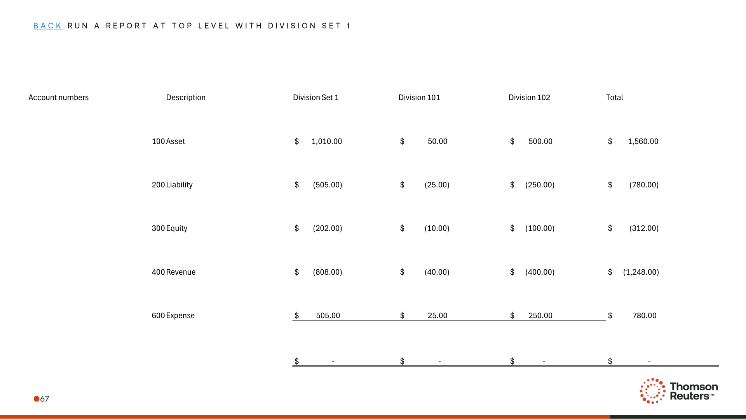
Figure: PDF page 71
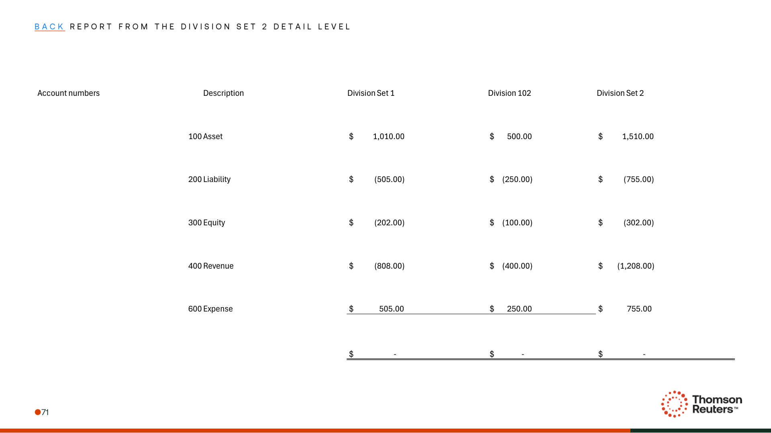
Figure: PDF page 72
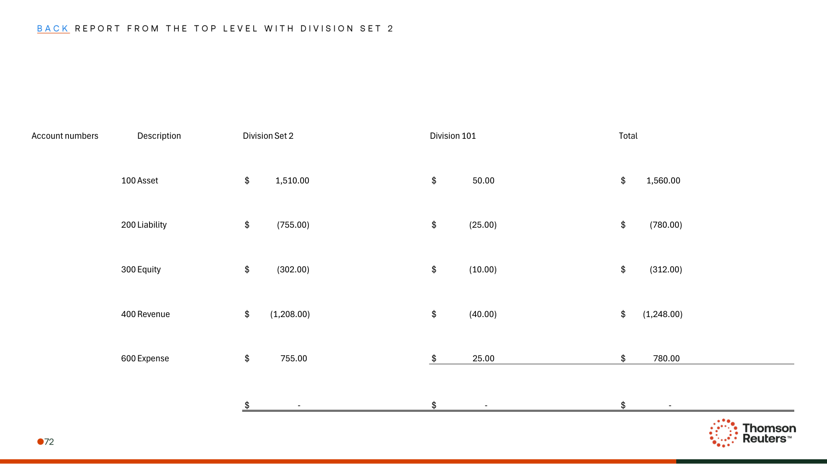

Appendix: Links
ADO Epic Link: https://dev.azure.com/tr-tax/TaxProf/_workitems/edit/4233299

